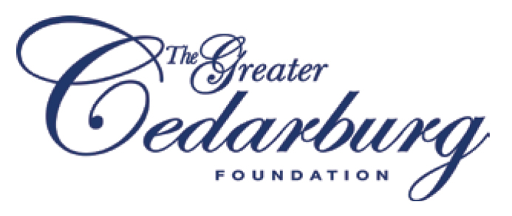

For Immediate Release Contact: Gail Ostermann

April 12, 2016 414-640-8154

**CEDARBURG FIRE DEPARTMENT**

**TO RECEIVE GCF CIVIC AWARD**

CEDARBURG — In a break from tradition, the Greater Cedarburg Foundation (GCF) has chosen to honor an organization rather than an individual as the recipient of its annual Civic Award. This year the award will be given to the Cedarburg Volunteer Fire Department, which is celebrating its 150th anniversary in 2016.

“We cannot think of a more dedicated volunteer group that daily exemplifies what service to the community means,” said Dale Lythjohan, chairman of the GCF civic event committee. Although this award has been given to individuals over the previous 13 years, Lythjohan said that making the presentation to the Fire Department is a “unique once-in-a-lifetime opportunity.”

The Cedarburg Fire Department was organized by a group of Cedarburg pioneers in the fall of 1866, a year after the American Civil War ended. The original roster included 31 men and the first piece of apparatus, a hand pumper named “Metamora No. 2,” was purchased from the City of Milwaukee for $800. Today, the department has 65 active members, 19 of whom are female, and 125 passive or honorary members who help with fund-raising efforts. The latest piece of equipment, a new Pierce fire truck scheduled to arrive the end of May, has a pricetag of $780,000.

Offering both fire and emergency medical services, the Cedarburg Fire Department averages more than 1,000 calls per year, according to Fire Chief Jeff Vahsholtz. The department serves a 33-square-mile area that includes both the City and Town of Cedarburg and is ranked in the top 3% of volunteer departments in the nation, Vahsholtz said.

The fire department holds four annual Maxwell Street Days events at Firemen’s Park on the northern edge of Cedarburg’s historic district. The event has been a tradition for 50 years, bringing thousands of people into the community and raising significant funds to support the department’s mission. The department also takes a leadership role in educating the public about fire safety, offering a Survive Alive House on the second floor of the firehouse and an annual Safety Day program held at Firemen’s Park every October.

The award presentation will be made Wednesday, May 11, during an event that will begin with an open house at 6:30 p.m. at the firehouse on Mequon Avenue. The awards ceremony, which will also recognize the 2016 GCF grant recipients, will start at 7:15 p.m. The event is open to the public. An RSVP is requested by May 4 by calling Rachel Bennett at the Greater Cedarburg Foundation at 414-336-7064.

Previous recipients of the Civic Award include Merlin Rostad, Carl Edquist, Ralph Huiras, Bob Armbruster, Edward Rappold, Janet and Don Levy, Mal Hepburn, Barbara and Layton Olsen, Jim and Sandy Pape, Jim Coutts, Paul and Philia Hayes, Jim Lee and Dick Dieffenbach.

The Greater Cedarburg Foundation has assets of more than $3 million comprised of an endowment and donor advised funds which distributes grants to non-profit organizations. The foundation’s mission is to preserve the local cultural heritage, enhance artistic endeavors and support educational, social and community-based services in the Greater Cedarburg area.

-end-